A PICTORIAL ESSAY ON THE AFRICAN COMMUNITY ISSUES

The African continent faces various social, economic and political challenges that have a significant impact on the community’s well-being. There are some issues that have plagued the African community for many years. Some of the include; poverty, corruption, conflict, disease, education, just to mention but a few. These issues are complex and interrelated and can only be suppressed by working together so as to help create a better future.

The number one issue is, poverty. Despite Africa having rich natural resources, poverty is one of the most significant issues facing the community. Many African countries struggle to provide basic necessities which worsens the problem of poverty. Some of the necessities they struggle with include; clean water, health care and education.

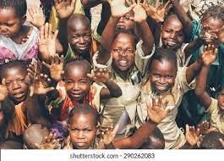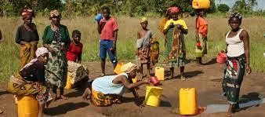

Secondly, corruption is another widespread problem in many countries. Corrupt government officials often siphon off public funds, making it difficult for the government to provide necessary services to their citizens.

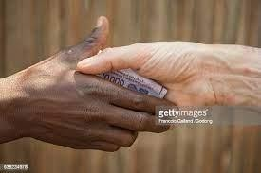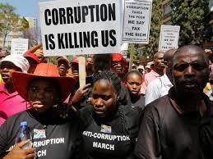

On the third issue, which is conflict which can be both within and between countries. They have also resulted in the displacement of millions of people, loss of life and destruction of infrastructure.

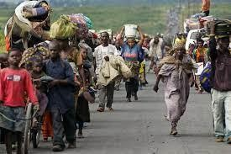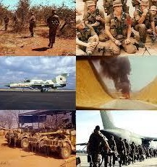

The other one is, education as many countries struggle to provide quality education to citizens which limits their ability to compete on the global stage. For this reason, Africans are considered illiterate and not learned.

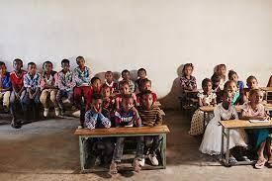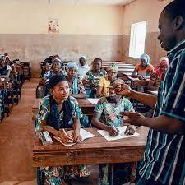

Gender inequality is another issue whereby, women in Africa face numerous challenges including the limited access of education, health care and job opportunities, as they are said to be more likely to live in poverty than men.

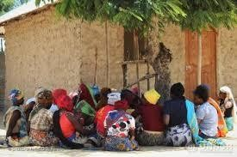

Environmental degradation is another one whereby Africa has experienced degradation due to factors such as deforestation, desertification and overfishing. This affects agriculture, water supply and biodiversity.

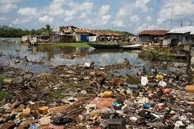

In conclusion, addressing these issues will require a comprehensive approach that includes investment in infrastructure, education and healthcare, promotion of good governance and protection of human rights. It will also require the involvement of the international community in providing financial and technical assistance to support and the development efforts of these countries.

There are many inspiring individuals and organizations working to create positive change in the communities and progress has already been made in several areas such as; reducing extreme poverty and improving access to education and healthcare. Also by continuing working together and addressing these issues, it will help in creating a better future for all.